JADAVPUR UNIVERSITY

**BRAIN MR IMAGE SEGMENTATION USING RBF KERNEL IN SVM**

BY

**SHRUTI PATHAK**

CLASS ROLL NO.: **002210503021**

EXAM ROLL NO.: **MCA**

REGISTRATION NO.: **163613 of 2022 - 2023**

Under the supervision of

**Prof. ( Dr. ) Jamuna Kanta Sing**

Project submitted in partial fulfillment for the Degree of

**MASTER OF COMPUTER APPLICATION**

In 2024

In the

Department of Computer Science & Engineering

**FACULTY OF ENGINEERING & TECHNOLOGY**

**FACULTY OF ENGINEERING & TECHNOLOGY**

**JADAVPUR UNIVERSITY**

**To whom it may concern**

I hereby recommend that the project **“BRAIN MR IMAGE SEGMENTATION USING RBF KERNEL IN SVM”** has been

carried out by **SHRUTI PATHAK** (Registration No.: 163613 of 2022 - 2023, Class Roll No.: 002210503021, Exam Roll No.: MCA ) under my guidance and supervision and be accepted in partial fulfillment of the requirement for the degree of **MASTER of COMPUTER APPLICATION** in **DEPARTMENT of COMPUTER SCIENCE and ENGINEERING**, **JADAVPUR UNIVERSITY**, during the academic year 2023-2024.

**Prof. (Dr.) Jamuna Kanta Sing** **Prof. Nandini Mukhopadhyay**

Project supervisor Head of the Department

Dept. of Comp. Science & Engineering Dept. of Comp. Science & Engineering

Jadavpur University, Kolkata-32 Jadavpur University, Kolkata-32

**Prof. Ardhendu Ghosal**

Dean , Faculty Council of Engineering & Technology

Jadavpur University, Kolkata 32

**CERTIFICATE OF APPROVAL**

This is to certify that the project entitled “**BRAIN MR IMAGE SEGMENTATION USING RBF KERNEL IN SVM**” is a bonafide record of work carried out by **SHRUTI PATHAK**  in partial fulfillment of the requirements for the award of the degree of **MASTER of COMPUTER APPLICATION** in the **DEPARTMENT of COMPUTER SCIENCE & ENGINEERING**, **JADAVPUR UNIVERSITY**. It is understood that by this approval the undersigned do not necessarily endorse or approve any statement made, opinion expressed or conclusion drawn therein but approve the project work only for the purpose for which it has been submitted.

--------------------------------- ---------------------------------

Signature of Examiner 1 Signature of Examiner 2

Date : Date :

**DECLARATION OF ORIGINALITY AND COMPLIANCE OF ACADEMIC PROJECT**

I hereby declare that this thesis work holds literature survey and original research work by the undersigned candidate, as a student of **MASTER OF COMPUTER APPLICATION.**  All the information in this document have been obtained and presented in accordance with academic rules and ethical conduct. I also declare that, as required by these rules and conduct, I have fully cited and referenced all the material results that are not original to this work.

**NAME:** SHRUTI PATHAK

**EXAMINATION ROLL NUMBER:**

**PROJECT TITLE:** BRAIN MR IMAGE SEGMENTATION USING RBF KERNEL IN SVM.

**SIGNATURE WITH DATE:**

**ACKNOWLEDGEMENT**

With my most sincere and gratitude, I would like to thank **Prof. (Dr.) Jamuna Kanta Sing**, **Department of Computer Science & Engineering**, my supervisor, for his overwhelming support throughout the duration of this project. His motivation always gave me the required inputs and momentum to continue with my work, without which the project work would not have taken its current shape. His valuable suggestion and numerous discussions have always inspired new ways of thinking. I feel deeply honored that I got this opportunity to work under him. I would like to express my sincere thanks to all my teachers for providing sound knowledge base and co-operation.

I would like to thank all the faculty members of the Department of Computer Science & Engineering of Jadavpur University for their continuous support. Last, but not the least, I would like to thank my batch mates for staying by my side when I needed them the most.

**SHRUTI PATHAK**

Class Roll No.: 002210503021

Exam Roll No.: MCA

Reg. No.: 163613 of 2022 - 2023

Signature with Date:

**INDEX**

**TOPIC PAGE NO.**

**1 ) Introduction :** .................. 8 - 18

1.1 ) Image Segmentation : .................. 9

1.2) Brain MR Image Segmentation : .................. 10 - 12

A ) Need Of Brain MR Image Segmentation : .................. 10 - 11

B ) Challenges in Segmenting Brain Structures : .................. 11 - 12

1.3 ) Technique of Brain MR Image Segmentation : ................ 12 - 18

A ) Intensity-Based Approaches : .................. 12 - 13

i ) Thresholding : .................. 13

ii) Region-Based : .................. 13

iii) Clustering : .................. 13

B ) Machine Learning : .................. 14 - 18

i) Traditional : .................. 14 – 17

ii) Deep Learning : .................. 17 - 18

C ) Hybrid Segmentation Approaches : .................. 18

**TOPIC PAGE NO.**

**2 ) Proposed Method:** .................. 19

2.1 ) Description: ..................

A) Architecture: ..................

B) Mathematical Background: ..................

C) How it works? ..................

D) Visual Representation ..................

2.2) Training: ..................

2.3) For Image Segmentation: ..................

**3 ) Experiments & Results :** .................

3.1 ) Database: ..................

A) Data Extraction: ..................

B ) Preproccessing: ..................

C ) Segmentation: ..................

3.2) Evaluation Metrics: ..................

3.3 ) Results: ..................

**4 ) Conclusion :**  ..................

**5 ) References :**  ..................

**1 ) Introduction :**

**In medical image analysis, image segmentation is a fundamental task, especially when it comes to brain MRIs (Magnetic Resonance Imaging). It is essential for several applications, including surgical planning, brain tissue classification, and tumor identification. Among the numerous segmentation methods available, the Radial Basis Function (RBF) [1] kernel in Support Vector Machine (SVM) [2] has gained significant attention and proven to be effective in handling the complexity and variability of brain MRI data.**

Image segmentation plays an important role in medical imaging, particularly when analyzing magnetic resonance imaging (MRI) scans of the brain. Since MRI offers detailed information on the brain, it is a valuable diagnostic and research tool for a wide range of neurological conditions. However, in order to extract useful information from these complex images, it is necessary to correctly segment the relevant brain structures.

The act of dividing an MRI scan of the brain into distinct areas or structures, such as white matter, gray matter, cerebrospinal fluid(CSF), and anatomical regions like the cortex, ventricles, or tumors, is known as brain MRI segmentation.

Accurate segmentation of brain MRI scans is complicated due to the inconsistencies and differences between brain structures, images, and the images obtained. To address these issues and produce dependable segmentation results, researchers and specialists have created a wide range of computational approaches, ranging from conventional image processing techniques to sophisticated machine learning and deep learning. It also provides an overview of commonly used segmentation techniques, highlighting their strengths, limitations, and future directions in the brain.

The RBF kernel of SVM proves to be an effective tool for brain MRI segmentation, skillfully managing complicated data. Its kernel functions accurately delineate brain structures by modeling complex interactions in an efficient manner. RBF's effectiveness in capturing tissue boundaries and accommodating intensity variations bolsters medical image analysis. From surgical planning to neurological research, RBF kernel helps with diagnosis, treatment planning, and advancements in neuro-imaging, and it promises further improvements in the use of MRIs.

**In this article, we investigate a distinctive approach using the Radial Basis Function (RBF) kernel in Support Vector Machine(SVM) for brain MR image segmentation across various data volumes with different noise and intensity. Our exploration aims to discern the kernel’s efficacy amidst diverse conditions, offering insights into its robustness and adaptability in real-world applications.**

**1.1 ) Image Segmentation :**

One popular technique for processing and analyzing digital images is image segmentation. Its goal is to separate the image into distinct sections or areas, usually using pixel attribute measurement. These concepts can influence how the foreground and background are separated, or they can group pixels together according to color or shape consistency. For instance, image segmentation is frequently used in medical science to recognize and label pixels or 3D voxels that represent tumors in the patient's brain or other organs.

To put it another way, image segmentation is the process of breaking apart an image into separate, recognizable areas or objects according to attributes like color, texture, shape, or brightness. The purpose of image segmentation is to simplify the image representation and transform it into a useful and identifiable form. In this process, each pixel is assigned a label so that pixels with similar characteristics can be placed in the same category.

Image segmentation is instrumental across multiple sectors. In medicine, it facilitates diagnosis and treatment planning by outlining organs and anomalies in images, while in satellite imagery, it supports land classification and disaster response efforts. Robotics and computer vision benefit from segmentation for object detection and navigation, while manufacturing relies on it for quality control. Similarly, in agriculture, segmentation aids in crop monitoring and yield estimation. Overall, segmentation enables precise analysis and automation, enhancing efficiency and decision-making in diverse domains.

Two types of image segmentation commonly used are:

* **Semantic Segmentation:** Semantic segmentation involves classifying each pixel in an image into predefined categories or classes, without distinguishing between instances of the same class. This type of segmentation assigns a label to every pixel in the image, resulting in a pixel-wise segmentation map that delineates different objects or regions.
* **Instance Segmentation:** Instance segmentation goes a step further than semantic segmentation by not only classifying pixels into categories but also distinguishing between individual object instances within the same class. In instance segmentation, each object instance in the image is uniquely identified and segmented, providing a more detailed understanding of the scene compared to semantic segmentation.

**1.2 ) Brain MR Image Segmentation :**

The brain, which is the body's central nervous system, controls speech, memory, cognition, and movement function in addition to acting as a warning system for body control. The rise in brain diseases caused by many factors like high stress, fast-paced lifestyle, stress on the brain and emotions, frequent injuries and the elderly has become more alarming in recent years. The health of people is gravely threatened by these circumstances.

Brain illnesses are commonly diagnosed in medicine using magnetic resonance imaging (MRI) equipment. The shape and function of the brain's tissues can be electronically visualized with magnetic resonance imaging (MRI), a cutting-edge medical procedure. Doctors can benefit from non-invasive, non-radiation, but more precise and superior solutions with comparable tissues by using this technique.

In general, brain image segmentation methods are categorized as intensity-based **[3]** , machine learning **[4]** , hybrid **[5]** etc. These methods are both progressive and collaborative. Segmenting (i) healthy brain tissues, (ii) brain sub-structures, and (iii) tumor and intra-tumor regions is the overall goal of the method. Conversely, a progressive approach makes the procedure more complex.

**1.2.A ) Need of Brain MR Image Segmentation :**

There are several reasons why a brain MRI - which produces incredibly precise image might be necessary. If doctors asked for an MRI of the brain, its not indicate to the worst case such as brain tumor or some other deadly condition. But the reality is that brain MRI is a diagnostic tool for a wide range of disorders involving the brain and spinal cord.

* Stroke:

When a blood artery in the brain becomes blocked or starts to bleed, a stroke **[6]** occurs. Within minutes, brain tissue begins to degrade due to this disturbance of oxygenated circulation. Brain MRI is a useful diagnostic technique for determining whether a cerebral hemorrhage or stroke has caused brain tissue damage. It helps medical professionals to evaluate damage and decide quickly on the best course of action. Medical professionals can identify the next steps required for successful therapy by using information from brain MRIs.

## Tumors or Cysts:

In addition to helping diagnose brain disorders, magnetic resonance imaging (MRI) scans can find small cysts **[7]** that CT scans might miss. In certain instances, doctors may administer an intracranial injection of a specialized contrast agent prior to the scan in order to enhance the visibility of various brain regions. Doctors are able to spot tumors and cysts that are challenging to detect with other procedures thanks to the better and more detailed images provided by this modern technology.

* **Traumatic Brain Injury** and Abnormalities **:**

The severity of traumatic brain injuries **[8]** can vary, and a brain MRI is an important tool to accurately diagnose the location and extent of the injury. It offers crucial details regarding the impact of the damage, such as brain swelling or hemorrhage. Doctors can evaluate brain MRI results to identify treatment plans based on the severity of injury, such as cerebral palsy, birth defects, etc.

* **Multiple Sclerosis :**

The degenerative disease known as multiple sclerosis (MS) **[9]** affects the brain and central nervous system, leading to an immune system attack on the tissue surrounding the nerves. To quantify the severity and course of multiple sclerosis, as well as to confirm a diagnosis, doctors frequently use brain MRI scans.

* **Aneurysms or Hemorrhages :**

Brain MRI is important for identifying aneurysms **[10]** and bleeding in the brain. A ruptured aneurysm can lead to serious consequences such as brain damage, stroke, and even death. By performing an MRI of the brain, doctors can detect aneurysms and measure their size and location, allowing timely intervention to prevent rupture.

Moreover, irregular blood flow in the brain can be found with an MRI scan. An abnormal blood flow can result in the brain receiving insufficient oxygen, which may result in a stroke or other brain damage. Doctors can diagnose these issues with a brain MRI and develop a suitable treatment plan to restore blood flow and lower the risk of further complications.

**1.2.B ) Challenges in Segmenting Brain Structures :**

Segmenting brain structures presents several challenges, including the complexity of anatomical variations across individuals, the presence of noise and artifacts in imaging data, and the difficulty in distinguishing between adjacent structures with similar intensity or contrast. These challenges often require sophisticated algorithms and manual interventions to achieve accurate segmentation results.

* **Different shapes :**

Brain tumors can develop anywhere in the brain and have a variety of functions. Without prior knowledge, this heterogeneity makes it challenging to develop a predictive model, particularly for tiny tumors.

* **Intensity inhomogeneity:**

The difficulty in segmentation arise from the uneven utilization of homogenous tissue and changes in spatial density in each dimension.

* **Bias field:**

The bias field **[11]** is caused by the defects in the acquisition sequences or radiofrequency coil imperfections, which also makes problems when segmenting.

* **Imbalance Data:**

It is a main problem in Brain segmentation. It is the inconsistent information on MR images. This uncertainty is due to regional differences between healthy and abnormal brain regions.

* **Data scarcity :**

For supervised segmentation techniques, insufficient data is a challenge for analyzing medical images, particularly when the brain is involved. Limited training data often leads to overfitting and have difficulty generalizing to new, unseen data.

**1.3 ) Techniques of Brain MR Image Segmentation :**

1.3.A ) Intensity-Based Approaches :

i ) Thresholding :

Thresholding [12, 13] is a simple image segmentation approach that uses reference histograms to determine a specific value, called the threshold $(τ)$ to distinguish between different classes. By specifying these thresholds, the segmentation process categorizes the pixels falling from the threshold, resulting in a segmented image.

The advantage of thresholding for image segmentation lies in its simplicity, speed, and computational efficiency, making it suitable for quickly separating objects or regions of interest based on intensity differences in images.

Thresholding is fast and computationally efficient method but sensitive to noise and intensity inhomogeneities. Although it use to separate background from the brain tissue in brain image segmentation.

ii ) Region-Based :

Region-based [14] methods help extract connected regions from an image based on predefined criteria such as pixel or voxel matching. This approach usually involves three steps: (a) select initial seed points, (b) identify points in objects or regions, and (c) select content-related points that start with similar results. In recent studies, regional methods have been widely used in the classification of brain tissue and show their effectiveness in this regard.

The advantage of using region-based methods for image segmentation lies in their ability to extract connected regions efficiently based on predefined criteria, facilitating the classification of complex structures like brain tissue accurately.

The main disadvantage of the region based method is its sensitivity to the initialization of seed point. By selecting a different seed point, the segmentation result can be completely different.

iii ) Clustering :

Clustering methods [5] are unsupervised segmentation techniques that group pixels/voxels with similar intensities in an image without relying on training data. These methods use the available image data to train themselves. segmentation and training happen in parallel by iterating between data clustering and estimating tissue class properties. The popular clustering methods are k-means clustering [15] and fuzzy C-means clustering [16] .

The advantage of using clustering methods for image segmentation lies in their ability to automatically group pixels/voxels with similar intensities, without requiring labeled training data, enabling unsupervised segmentation of images efficiently.

Clustering techniques may struggle with high-dimensional data and require predefined cluster numbers, making them sensitive to initialization and potentially leading to suboptimal results. Additionally, they might struggle with handling overlapping or irregularly shaped clusters, limiting their effectiveness in segmenting complex brain structures accurately.

1.3.B ) Machine Learning :

i ) Traditional Machine Learning :

Any fundamental algorithmic structure to solve given problem will come under Traditional Machine Learning **[17]** . These algorithms learn from the data, where choice of algorithm and features (inputs) to be fed into algorithm are made by subject matter experts. Traditional ML models expects all inputs are in the format of structured data like numbers. Traditional ML models can be used to solve classification, segmentation, regression, clustering, dimensionality reduction problems.

Some common types of traditional machine learning techniques used in brain MRI segmentation are: k-Nearest Neighbours (k-NN) **[18]** , Artificial Neural Networks (ANN) **[19]** , Radial Basis Functions (RBF) **[1]** , Support Vector Machines (SVM) **[2]** , etc.

* **k-Nearest Neighbours (k-NN) :**

The k-Nearest Neighbours (KNN) algorithm works by assigning a class label to an input sample based on the majority class among its k nearest Neighbours in feature space.

For image segmentation, KNN can be applied by treating each pixel or image patch as a data point with features derived from its intensity values or other characteristics, and then assigning a class label based on the majority class among its nearest Neighbours.

Advantages of KNN in image segmentation include its simplicity and ease of implementation, as well as its ability to handle multi-class classification tasks without assuming any underlying distribution of the data.

However, KNN's performance can be sensitive to the choice of the number of Neighbours (k) and the distance metric used, which may require careful tuning. Additionally, KNN can be computationally expensive, especially with large datasets, as it requires calculating distances between the query point and all training samples. Furthermore, KNN may not perform well in high-dimensional feature spaces or when dealing with noisy or irrelevant features.

* **Artificial Neural Networks (ANN) :**

Artificial Neural Networks (ANN) consist of interconnected nodes arranged in layers, including an input layer, one or more hidden layers, and an output layer. Each node applies a weighted sum of inputs followed by a non-linear activation function. During training, the network adjusts the weights to minimize the difference between predicted and actual outputs using techniques like backpropagation.

In image segmentation, Artificial Neural Networks (ANNs) work by processing input image data through interconnected layers of nodes, extracting features relevant to segmentation tasks. These features are then used to predict class labels or segmentation masks for each pixel or region in the image. Through training on labeled data, ANNs learn to map input images to corresponding segmentation outputs, optimizing their parameters to minimize prediction errors and accurately delineate object boundaries.

ANNs in image segmentation include their ability to capture complex relationships in data, adaptability to various image characteristics, and potential for high accuracy. Another advantage of Artificial Neural Networks (ANNs) in image segmentation is their capacity to learn from large datasets efficiently, enabling robust performance across diverse imaging modalities and complex segmentation tasks.

However, ANNs often require large amounts of labeled training data and significant computational resources for training, and they may be prone to overfitting if not properly regularized. Additionally, the interpretability of ANN-based segmentation models may be limited compared to simpler techniques like thresholding or clustering.

* **Radial Basis Functions (RBF) :**

Radial Basis Function Networks (RBF) are a type of artificial neural network that operates by mapping input data into a high-dimensional feature space using radial basis functions. The network consists of three layers: an input layer, a hidden layer with radial basis functions, and an output layer. During training, the centers and widths of the radial basis functions are adjusted to minimize the difference between predicted and actual outputs.

For image segmentation, RBF networks can be employed by treating pixel intensities or image features as input data and training the network to assign class labels to different regions of the image. RBF networks excel in capturing complex non-linear relationships in the data, making them well-suited for tasks like segmenting structures with irregular shapes or intensity distributions.

One advantage of RBF networks in image segmentation is their ability to approximate complex non-linear decision boundaries, allowing for accurate segmentation of intricate structures in images. Additionally, RBF networks are capable of handling high-dimensional feature spaces efficiently, making them suitable for segmentation tasks involving large and complex datasets. Another advantage of RBF networks is their inherent ability to generalize well to unseen data, thanks to their capability to model complex relationships between features and class labels. This enhances their robustness and ensures reliable performance even in scenarios with limited training data or noisy input images.

However, RBF networks may require careful tuning of hyperparameters, such as the number and distribution of radial basis functions, to achieve optimal segmentation performance. Moreover, training RBF networks typically requires a significant amount of computational resources, especially for large-scale image datasets, which can pose challenges in terms of time and computational cost. Despite these challenges, RBF networks remain a powerful tool for image segmentation, particularly in scenarios where capturing complex relationships in the data is crucial for achieving accurate segmentation results.

* **Support Vector Machines (SVM) :**

Support Vector Machines (SVM) work by finding the optimal hyperplane that best separates data points into different classes, maximizing the margin between them. In image segmentation, SVM can be employed to classify pixels or image regions into different classes based on features extracted from the images.

Advantages of SVM in image segmentation include its ability to handle high-dimensional feature spaces efficiently, robustness against overfitting, and effectiveness in handling non-linear decision boundaries through kernel tricks.

However, SVMs may struggle with large datasets due to their computational complexity, and they require careful selection of hyperparameters. Additionally, SVMs might not perform optimally when dealing with highly imbalanced datasets, where certain classes are underrepresented.

Here are some different kernels of SVM and their usage in image segmentation, along with their advantages and disadvantages:

* **Linear Kernel:**

The linear kernel **[20]** is the simplest form of SVM, where the decision boundary is a straight line. Linear SVM can be used for image segmentation tasks where the classes are linearly separable, or when a simple decision boundary is sufficient.

**Advantages**: Computational efficiency, easy to interpret.

**Disadvantages**: Limited ability to capture non-linear relationships in the data.

* **Polynomial Kernel:**

The polynomial kernel **[21]** maps data into higher-dimensional space and computes the decision boundary using polynomial functions. Polynomial SVM can capture more complex decision boundaries than the linear kernel, making it suitable for image segmentation tasks with moderately complex class distributions.

**Advantages**: Can capture non-linear relationships in the data.

**Disadvantages**: May be sensitive to the choice of hyperparameters such as the degree of the polynomial.

* **Radial Basis Function (RBF) Kernel :**

The RBF kernel **[ 22]** maps data into an infinite-dimensional space and computes the decision boundary using radial basis functions. RBF SVM is highly flexible and can capture complex non-linear relationships in the data, making it suitable for image segmentation tasks with complex class distributions.

**Advantages**: High flexibility, effective in high-dimensional spaces, robust to overfitting.

**Disadvantages**: Computationally expensive, may require careful tuning of hyperparameters.

* **Sigmoid Kernel:**

The sigmoid kernel **[23]** computes the decision boundary using sigmoid functions. Sigmoid SVM can capture non-linear relationships similar to polynomial and RBF kernels, but it may not perform as well in practice for image segmentation tasks.

**Advantages**: Can capture non-linear relationships, may perform well in certain cases.

**Disadvantages**: Less commonly used, may not generalize as well as other kernels.

In image segmentation tasks, the choice of kernel depends on the complexity of the problem, the distribution of classes in the image, computational resources, and other factors. Experimentation with different kernels and hyperparameters is often necessary to find the best-performing model for a particular segmentation task.

ii ) Deep Learning :

Deep learning [24, 25] encompasses a range of neural network architectures, notably Convolutional Neural Networks (CNNs) [26] , which excel in learning hierarchical features from data. For image segmentation, deep learning works by training CNNs to predict segmentation masks directly from input images, leveraging the network's ability to capture complex spatial relationships and features.

Advantages of deep learning for image segmentation include its capability to automatically learn intricate patterns and features from data, adaptability to various imaging modalities and structures, and state-of-the-art performance in many segmentation tasks.

However, deep learning models often require large amounts of labeled data for training, extensive computational resources, and time for training. Overfitting can also be a concern, especially with limited training data, and deep learning models may lack interpretability compared to traditional techniques. Additionally, deploying and fine-tuning deep learning models can be challenging, requiring expertise in both machine learning and domain-specific knowledge.

1.3.C ) Hybrid Segmentation Approaches :

Brain MRI segmentation problems need to be continuously investigated and new methods introduced. Selecting the most appropriate technique for a given application can be difficult and often requires a combination of techniques to achieve accurate segmentation. Therefore, the hybrid or combined segmentation method [5] has gained great popularity in many brain MRIs. There are three sub category of Hybrid Segmentation Approaches :- a ) contour-based and machine learning, [27] (ii) metaheuristic, and machine learning [28] and (iii) deep learning and machine learning [29].

Several examples of hybrid brain MRI segmentation methods have been developed. Kapoor et al. [30] Segmentation of multiple brain tissues in adults in 2D MRI using a combination of Contour-Based and Machine Learning. Masutani et al. [31] Combining model-based region growth with local quality information for accurate segmentation of cerebral vessels. An unsupervised brain MRI segmentation is developed by Xue et al. [32] by combining minimum error global thresholding and a spatial-feature-based *FCM* clustering to segment 3D MRI in a “slice-by-slice” manner.

The main disadvantage of the hybrid (combined) segmentation method is its complexity, usually compared to the individual method. This challenge requires more time and more parameters to be adjusted for specific applications. Therefore, the design of the hybrid segmentation method must be carefully considered to ensure efficiency and high-quality segmentation results.

**2 ) Proposed Method :**

**In this project, a Radial Basis Function (RBF) Kernel in Support Vector Machine (SVM) is employed specifically for the segmentation of brain MR images into white matter, grey matter, and cerebrospinal fluid (CSF) regions. This methodology harnesses the unique capabilities of RBF Kernel to accurately delineate these crucial anatomical structures, thereby facilitating more precise medical image analysis and aiding in the diagnosis and treatment planning of neurological conditions. By leveraging the RBF kernel's capacity to capture intricate relationships within the image data, this research contributes to advancements in brain MR image segmentation techniques, enhancing our understanding of brain anatomy and pathology.**

**2.1 ) RBF Kernel in SVM:**

1. **) Experiments & Results :**

**3.1) Database:**

The dataset of this study is downloaded from BrainWeb. The BrainWeb is acquired from the McConnell Brain Imaging Center of the Montreal Neurological Institute, McGill University . This database contains a set of realistic MRI data produced by an MRI simulator.

**BainWeb** - Database of human brain images derived from a realistic phantom and generated using a sophisticated MRI simulator. Custom simulations may be generated to match a user's selected parameters. The goal is to aid validation of computer-aided quantitative analysis of medical image data. The SBD contains a set of realistic MRI data volumes produced by an MRI simulator. These data can be used by the neuroimaging community to evaluate the performance of various image analysis methods in a setting where the truth is known. The SBD contains simulated brain MRI data based on two anatomical models: normal and multiple sclerosis (MS). For both of these, full 3-dimensional data volumes have been simulated using three sequences (T1-, T2-, and proton-density- (PD-) weighted) and a variety of slice thicknesses, noise levels, and levels of intensity non-uniformity (INU) . These data are available for viewing in three orthogonal views (transversal, sagittal, and coronal), and for downloading.

 As “Ground Truth” we use the discrete anatomical model which consists of a class label (integer) at each voxel, representing the tissue which contributes the most to that voxel (0=Background, 1=CSF, 2=Grey Matter, 3=White Matter, 4=Fat, 5=Muscle/Skin, 6=Skin, 7=Skull, 8=Glial Matter, 9=Connective).

The BrainWeb dataset in our work consists of 11 T1-weighted MRI volumes, each yielding 51 images of dimensions 181 pixels by 217 pixels, constituting a rich repository of neuroimaging data. Notably, these volumes are intentionally afflicted with varying degrees of noise and intensity non-uniformity (INU), as meticulously delineated in **Table 1.** This deliberate manipulation accurately simulates the complexities encountered in real-world MRI scans, rendering the dataset invaluable for benchmarking and validating image processing algorithms. By encapsulating a diverse spectrum of noise and intensity variations, the BrainWeb dataset serves as a crucial resource for advancing computational techniques aimed at enhancing image quality, facilitating segmentation, and extracting meaningful features from neuroimaging data. Its meticulous characterization of noise and INU levels underscores its utility in fostering innovation and excellence in medical image analysis and neuroimaging research, positioning it as a cornerstone in the pursuit of enhanced diagnostic accuracy and clinical utility in MRI-based procedures.

**Table 3.1: Information about the simulated MRI image Volumes:**

|  |  |  |  |  |  |  |  |  |  |  |  |
| --- | --- | --- | --- | --- | --- | --- | --- | --- | --- | --- | --- |
|  | **Volume 1 (%)** | **Volume 2 (%)** | **Volume 3 (%)** | **Volume 4 (%)** | **Volume 5(%)** | **Volume 6 (%)** | **Volume 7 (%)** | **Volume 8 (%)** | **Volume 9 (%)** | **Volume 10 (%)** | **Volume 11 (%)** |
| Noise | 0 | 1 | 1 | 3 | 3 | 5 | 5 | 7 | 7 | 9 | 9 |
| INU | 0 | 20 | 40 | 20 | 40 | 20 | 40 | 20 | 40 | 20 | 40 |

### 3.1.A) Data Extraction :

In my project, I conducted an extensive exploration of the BrainWeb dataset, focusing on extracting volumes with varying degrees of noise and intensity non-uniformity (INU). Utilizing raw data files (RAWB) from the BrainWeb dataset, I developed a pipeline to extract these volumes and convert them into portable graymap (PGM) files, a common format for representing grayscale images. Leveraging Python programming, I then transformed the PGM files into the more widely used JPEG format for easier visualization and analysis. This comprehensive preprocessing approach allowed me to generate a diverse dataset of brain volumes, each representing different levels of noise and INU distortions. These volumes serve as invaluable resources for training and evaluating algorithms aimed at mitigating the effects of noise and INU in magnetic resonance imaging (MRI) data. To assess the accuracy of the Radial Basis Function (RBF) model, I employed these varied volumes as input data. By systematically evaluating the model's performance across different noise levels and INU variations, I aimed to comprehensively understand its robustness and generalization capabilities. Fig: 3.1 displays MRI images with varying percentages of noise and intensity non-uniformity (INU).

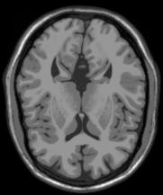 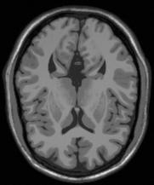 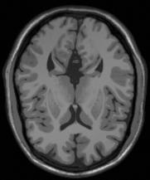 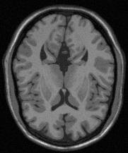 **(a) (b) (c) (d)**

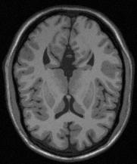 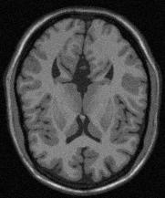 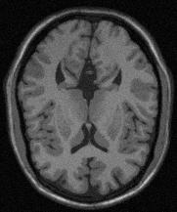 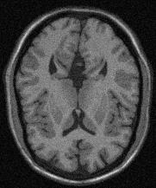

**(e) (f) (g) (h)**

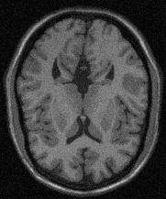 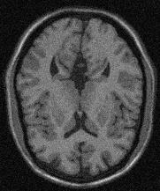 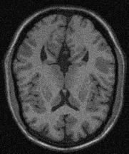

**(i) (j) (k)**

**Fig: 3.1 – A random slice (slice– 75) from every volumes:** (a) noise- 0% INU- 0% (b) noise- 1% INU- 20% (c) noise- 1% INU- 40% (d) noise- 3% INU- 20% (e) noise- 3% INU- 40% (f) noise- 5% INU- 20% (g) noise- 5% INU- 40% (h) noise- 7% INU- 20% (i) noise- 7% INU- 40% (j) noise- 9% INU- 20% (k) noise- 9% INU- 40%

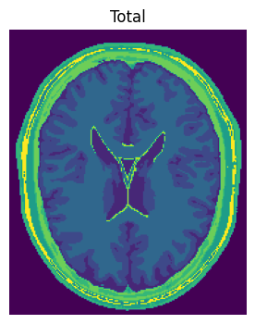

(a)

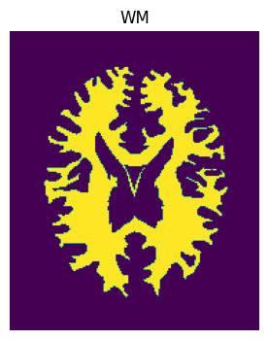 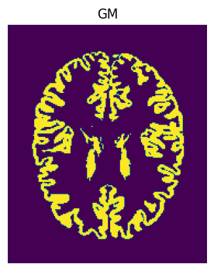 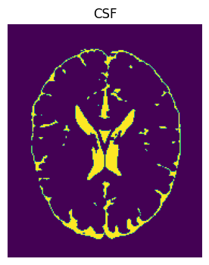

**(b) (c) (d)**

**Fig: 3.2 - Ground truth images of a random slice( Slice – 90) from volume - 1 of the simulated brain MRI images: (a) Total; (b) WM; (c) GM; (d) CSF.**

### 3.1.B) Preproccessing :

A vast amount of anatomical and functional information is made possible by medical imaging technologies, and this information, when combined with quantitative image processing tools, improves patient care and diagnosis. Pre-processing brain MR images is a basic step in ensuring that the quantitative image analysis pipeline produces a good output. The preprocessing stage consists of many operations designed to either enhance its quality or removal of the non-brain tissues. The groundwork for precise and trustworthy segmentation is laid during this initial stage.

* **Skullstipping:**

Skull stripping, a crucial step in preprocessing MRI images for segmentation, involves the removal of non-brain tissues such as the skull and scalp to focus specifically on the brain structures. This process is essential to ensure accurate segmentation results by eliminating extraneous information that may interfere with the analysis. Various techniques can be employed for skull stripping, ranging from simple thresholding methods to more sophisticated algorithms like Brain Extraction Tool (BET) or machine learning-based approaches. By effectively isolating the brain from surrounding tissues, skull stripping sets the stage for subsequent segmentation processes, enabling precise delineation of anatomical structures and enhancing the overall quality of quantitative image analysis for improved patient care and diagnosis.

In my project, I developed a custom skull stripping algorithm to preprocess MRI images, a pivotal step in medical image analysis pipelines. Leveraging Python and libraries such as NumPy and scikit-image, the algorithm automates the removal of non-brain tissues, particularly the skull and scalp, from the images. By implementing intensity thresholding and a depth-first search (DFS) approach, the algorithm accurately identifies and isolates the skull region. Additionally, it incorporates techniques to handle variations in image intensity and size, ensuring robust performance across diverse datasets. The resulting "skull-stripped" images exhibit enhanced clarity and focus specifically on the brain structures, setting the stage for subsequent segmentation and analysis tasks. After applying skull stripping, any pixels outside of the brain were mapped to zero as background. **Fig. 6** shows the effect of this step for a sample slice.

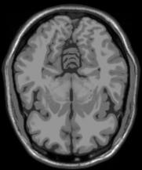 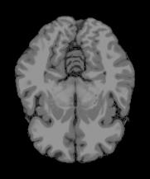

(a) (b)

**Fig: 3.3 – (a) Before Skull-Stripping and (b) After Skull-Stripping of a random slice (slice- 65) from volume – 1**

* **Normalisation :**

In preprocessing, normalization is a crucial step to ensure that numerical data is on a standardized scale, typically between 0 and 1 or -1 and 1. By scaling the features to a common range, normalization prevents certain features from dominating the learning process due to differences in their scales. It enables machine learning algorithms to converge faster and often leads to better performance. Common methods include Min-Max Scaling, Z-score Standardization, Robust Scaling, and Unit Vector Scaling, each suited to different data distributions and modeling requirements.

In my project, I employed a straightforward yet effective method for normalizing pixel intensities in the preprocessing stage. By dividing each pixel intensity by the maximum intensity value, I ensured that all pixel values were scaled to a range between 0 and 1. This normalization step is crucial for enhancing the performance of machine learning algorithms, as it helps prevent certain features from dominating others solely due to their larger scale. Moreover, by bringing all pixel values into a common range, the model can better discern patterns and relationships within the data, leading to more accurate and robust predictions. This simple yet powerful normalization technique lays a solid foundation for the subsequent stages of the project, facilitating the extraction of meaningful insights and the development of reliable models.

### 3.1.C) Segmentation :

In this study, we use the Radial Basis Function (RBF) kernel of the Support Vector Machine (SVM) for segmenting brain MRI volumes into white matter, grey matter, and cerebrospinal fluid (CSF), accommodating variations in noise and intensity non-uniformity (INU) percentages across multiple volumes. Employing Python's SVC (Support Vector Classifier) function, our approach demonstrates robustness and accuracy in achieving precise segmentation across volumes with diverse noise and INU percentages. By systematically applying the SVC with the RBF kernel to each volume, we ensure comprehensive analysis that captures the inherent variability present in real-world MRI data. This meticulous approach enables us to account for nuanced anatomical features and variations, yielding reliable segmentation results that generalize effectively across different imaging conditions.

* **Splitting the datasets:**

After preproccessing each volumes, to validate the segmentation model's performance, we divide each preprocessed dataset into training and testing sets, following an 80-20 ratio. This partitioning strategy guarantees an adequate amount of data for training while retaining a separate portion for unbiased evaluation.

* **Standardization:**

Before training the SVM model, we standardize the features within the training set using the StandardScaler from the scikit-learn library. Standardization ensures that each feature has a mean of 0 and a standard deviation of 1, which can improve the convergence of the SVM algorithm.

* **Training the SVM Model:**

We then train an SVM model using the Radial Basis Function (RBF) kernel on the standardized training data. The RBF kernel is well-suited for capturing complex relationships in high-dimensional data, making it suitable for MRI segmentation tasks. During training, the SVM learns to classify each voxel based on its feature representation.

* **Testing:**

After training the SVM model, we evaluate its performance on the held-out testing set. We apply the trained model to classify each voxel in the testing volumes into CSF, grey matter, or white matter. We assess the segmentation accuracy using metrics such as accuracy score, precision, recall, and f1 score.

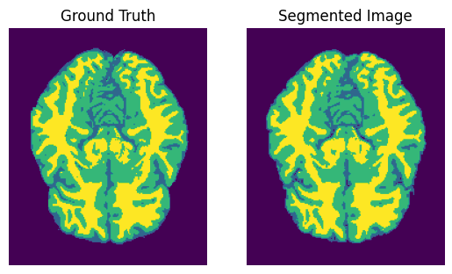

**Fig: 3.4 – After Segmentation The original ground truth and the segmented image of a random slice (slice- 61) from volume – 1**

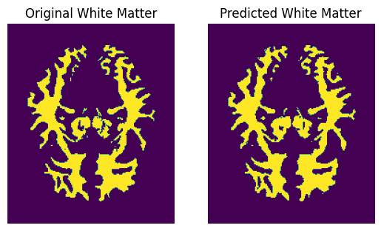

**Fig: 3.5 – The original white matter and the predicted white matter of a random slice (slice- 61) from volume – 1**

**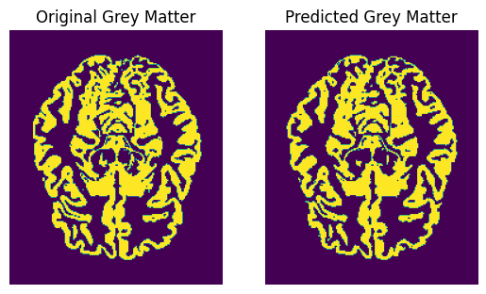  
Fig: 3.6 – The original grey matter and the predicted grey matter of a random slice (slice- 61) from volume – 1**

**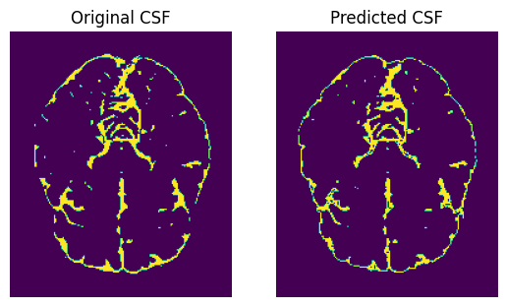  
Fig: 3.7 – The original CSF and the predicted CSF of a random slice (slice- 61) from volume – 1**

**3.2) Evaluation Metrics :**

In this Experimentation, Accuracy Score and F1 Score is general commonly

used method. F1 Score is one of the most widely used evaluation metrics. F1 Score provides a more balanced evaluation on imbalanced dataset also. F1 Score not only considers True Positives (TP) but also considers both false positives (FP) and false negatives (FN). Firstly we have to compute Precision and Recall. Precision and Recall can be computed using the equation mentioned below –

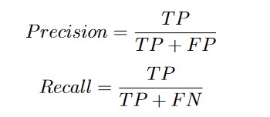

In above equations, TP, FP, FN represent True Positive (Model has predicted Positive class whether it is actually positive), False Positive (Model has predicted Positive class whether it is actually negative) and False Negative (Model has predicted Negative class whether it is actually positive) respectively. Accuracy Score and F1 Score can be computed using the equation mentioned below –

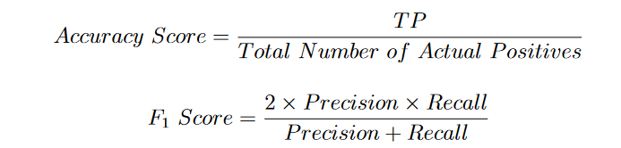

Accuracy Score and F1 Score both lie between [0,1], higher the values better Recognition has been done.

**3.2) Results:**

**4) Conclusion:**

The utilization of medical image segmentation in real clinical settings is a crucial aspect that warrants significant attention. Image segmentation is an essential step in many medical applications that involve 3D visualization, computer-aided diagnosis, measurements, and registration. Without a doubt, computerized segmentation techniques have demonstrated their usefulness and potential for computer-aided diagnosis and treatment planning. This work has given a thorough review of the basic ideas and frequently used techniques for human brain MRI segmentation.

New segmentation problems for diverse applications keep coming up as a result of the ongoing and quick development of medical models; this leads to ongoing study and the introduction of new techniques. As was previously indicated, in many circumstances, combining multiple strategies will be essential to achieve the intended segmentation goal.

In this paper, we have demonstrated the effectiveness of utilizing the Radial Basis Function (RBF) kernel of Support Vector Machines (SVM) for segmenting brain MRI images. Through our implementation, we achieved promising outcomes in accurately delineating brain structures into cerebrospinal fluid (CSF), grey matter, and white matter regions.

Precise segmentation was made possible by the RBF kernel of SVM, which demonstrated exceptional skill in identifying intricate patterns and correlations in the high-dimensional MRI data. We were able to obtain reliable segmentation results by utilizing the SVM's capacity to identify ideal decision boundaries in feature space.

Although our focus was on SVM-based segmentation, it's essential to acknowledge the potential of alternative methods, such as deep learning approaches, in this domain. While our study showcased the efficacy of the RBF kernel of SVM, future research could explore the integration of convolutional neural networks (CNNs) or other deep learning architectures for MRI segmentation tasks.

It is important to acknowledge that the proposed algorithm is not without challenges. The increased complexity and computational requirements may lead to longer processing times. However, it is hopeful that future advancements and refinements of the RBF kernel of SVM will further elevate its accuracy and efficiency.

Ultimately, our research emphasizes the usefulness of the SVM's RBF kernel as a consistent and efficient method for brain MRI segmentation. By accurately delineating brain structures, this approach contributes to advancing our understanding of neuroanatomy and holds potential for enhancing clinical diagnosis and treatment planning in neurological disorders.

**5) References:**

1. Bo Feng, Meihua Zhang, Hanlin Zhu, Lingang Wang, Yanli Zheng, “MRI Image Segmentation Model with Support Vector Machine Algorithm in Diagnosis of Solitary Pulmonary Nodule”, Contrast Media Mol Imaging. 2021;
2. Andriy Myronenko, Xubo Song, “Intensity-based image registration by minimizing residual complexity”, IEEE Trans Med Imaging. 2010 Nov; 29(11): 1882-91.
3. Hyunseok Seo, Masoud Badiei Khuzani, Varun Vasudevan, Charles Huang, Hongyi Ren, Ruoxiu Xiao, Xiao Jia, Lei Xing1, “Machine Learning Techniques for Biomedical Image Segmentation: An Overview of Technical Aspects and Introduction to State-of-Art Applications”, Med Phys. 2020 Jun; 47(5): e148–e167.
4. Ivana Despotovic, Bart Goossens, Wilfried Philips, “MRI Segmentation of the Human Brain: Challenges, Methods, and Applications ”, Computational Intelligence Techniques in Medicine, Vol-2015, Article ID 450341, 2015.
5. R. Gilberto González, “Clinical MRI of Acute Ischemic Stroke”, J Magn Reson Imaging. 2012 Aug; 36(2): 259–271.
6. Evangelos Perdikakis, Vasilios Skiadas “MRI characteristics of cysts and “cyst-like” lesions in and around the knee: what the radiologist needs to know”, Insights Imaging. 2013 Jun; 4(3): 257–272.
7. Bruce Lee, Andrew Newberg, “Neuroimaging in Traumatic Brain Imaging”, NeuroRx. 2005 Apr, 2(2): 372–383.
8. Christopher C. Hemond, Rohit Bakshi “Magnetic Resonance Imaging in Multiple Sclerosis”, Cold Spring Harb Perspect Med. 2018 May; 8(5): a028969.
9. Jill Novitzke, “The Basics of Brain Aneurysms: A Guide for Patients”, J Vasc Interv Neurol. 2008 Jul; 1(3): 89–90.
10. C. M. Collins, W. Liu, W. Schreiber, Q. X. Yang, and M. B. Smith, “Central brightening due to constrctive interference with, without, and despite dielectric resonance,” Journal of Magnetic Resonance Imaging , vol. 21, no. 2, pp. 192–196, 2005.
11. M. Sezgin and B. Sankur, “Survey over image thresholding techniques and quantitative performance evaluation,” Journal of Electronic Imaging , vol. 13, no. 1, pp. 146–168, 2004.
12. Sezgin M., Sankur B. Survey over image thresholding techniques and quantitative performance evaluation.Journal of Electronic Imaging*.* 2004
13. R. M. Haralick and L. G. Shapiro, “Image segmentation techniques,” Computer Vision, Graphics, and Image Processing, vol. 29, no. 1, pp. 100–132, 1985.
14. G. B. Coleman and H. C. Andrews, “Image segmentation by clustering,” Proceedings of the IEEE, vol. 67, no. 5, pp. 773–785, 1979.
15. J.C. Bezdek, R. Ehrlich, and W. Full, "FCM: The Fuzzy C-Means Clustering Algorithm," Computers & Geosciences, vol. 10, no. 2-3, pp. 191-203, 1984.
16. Zhan T., Shen F., Hong X., Wang X., Chen Y., Lu Z., Yang G. A glioma segmentation method using cotraining and superpixel-based spatial and clinical constraints. IEEE Access. 2018.
17. Runya Li, Shenglian Li, “Multimedia Image Data Analysis Based on KNN Algorithm”, Comput Intell Neurosci. 2022;
18. Ali Fawzi, Anusha Achuthan, Bahari Belaton, “ Brain Image Segmentation in Recent Years: A Narrative Review ”, Brain Sci. 2021 Aug; 11(8): 1055.


22. Zeynettin Akkus, Alfiia Galimzianova, Assaf Hoogi, Daniel L. Rubin, Bradley J. Erickson, “Deep Learning for Brain MRI Segmentation: State of the Art and Future Directions”, Journal of Digital Imaging 30, 449–459, 2017.
23. Srigiri Krishnapriya, Yepuganti Karuna, “ Pre-trained deep learning models for brain MRI image classification ”, Front. Hum. Neurosci., Sec. Brain-Computer Interfaces, Vol 17, 2023.
24. Olaf Ronneberger, Philipp Fischer, Thomas Brox, “U-Net: Convolutional Networks for Biomedical Image Segmentation”, MICCAI 2015.
25. Ma C., Luo G., Wang K. Concatenated and connected random forests with multiscale patch driven active contour model for automated brain tumor segmentation of MR images. IEEE Trans. Med. Imaging. 2018
26. Mishro P.K., Agrawal S., Panda R., Abraham A. A novel type-2 fuzzy c-means clustering for brain MR image segmentation.IEEE Trans. Cybern. 2020:1–12.
27. Ito R., Nakae K., Hata J., Okano H., Ishii S. Semi-supervised deep learning of brain tissue segmentation. Neural Netw. 2019
28. Kapur T., Eric W., Grimson L., Wells W. M., III, Kikinis R. Segmentation of brain tissue from magnetic resonance images.
29. Masutani Y., Schiemann T., Hohne K. H. Medical Image Computing and Computer-Assisted Interventation—MICCAI’98: Proceedings of the 1st International Conference Cambridge, MA, USA, October 11–13, 1998*.* Vol. 1496. Berlin, Germany: Springer; 1998. Vascular shape segmentation and structure extraction using a shape-based region-growing model
30. Xue J.-H., Pizurica A., Philips W., Kerre E., van de Walle R., Lemahieu I. An integrated method of adaptive enhancement for unsupervised segmentation of MRI brain images.